Types of Design Drawings
  - Key Revision Facts: GCSE Technology

There are a range of different types of design drawings

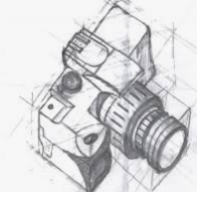
Freehand
A freehand drawing is drawn without using instruments such as a ruler or a pair of compasses.

Orthographic Projection
Orthographic Projection is a method of drawing a 3D object from different directions. Usually, a front, side, and plan view are drawn from each side's important details to be shown. There are two ways of drawing in orthographic - First Angle and Third Angle. They differ only in the position of the plan, front and side views.
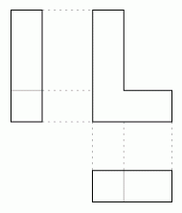
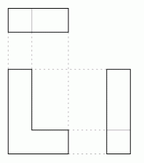
First Angle Third Angle

Working drawings
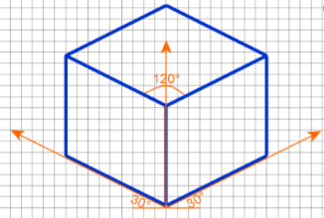
Working drawings contain the information needed to make an object, including: dimensions, components, materials, and assembly instructions.
Isometric Drawing
An isometric drawing is a type of 3D drawing that is set out using 30-degree angles.
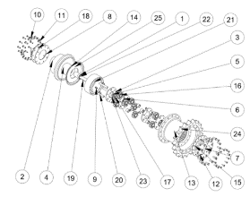
Perspective Drawing
Perspective Drawing is a technique used in art and design to represent three-dimensional images on a two-dimensional picture plane. Any perspective representation of a scene that includes parallel lines has one or more vanishing points in a perspective drawing.

Exploded Diagram
An exploded-view is commonly used for assembly drawings to show the relationship between different components and how they fit together.
System Diagram
A system diagram is a visual model of a system, its components, and its interactions.
Schematic Diagram
Schematic diagrams use symbols to show the layout of electrical or mechanical systems. A circuit diagram is a schematic that shows how components are connected.

Download
More Key Fact Revision sheets can be downloaded from
www.andrew-seaford.co.uk/revision

Version information
Date | Arthur | Comment
13-Mar-2021 | Andrew Seaford | Initial release.

